Data and Descriptive Statistics
Name
Institution
Date

- Research questions about a population.
Question 1.
What proportion of fourth-year students excelled in all units in the previous year at Harvard University?
Estimated prediction of the results: The predicted results are that above 50% of all the students excelled all the units.
Question 2.
What is the average mark of all Harvard University’s fourth-year students in a single unit?
Estimated prediction of the results: The predicted average mark is above 50% mark.
- Collecting data.
- Creates a survey and collects the data for responses to your proposed questions above.
For question 1. “Did you excel in all units, Yes or NO?”
For question 2. “How many marks did you have in a single unit?”
- Randomly selected 30 fourth year students where by 25 of the students were responsive and 5 of the students were against the idea.
- Raw data in column (categorical data) and in column 2 (numerical data)

Student marks
A | 54
B | 67
C | 70
D | 84
E | 56
F | 45
G | 87
H | 55
K | 56
J | 78
K | 68
L | 78
M | 56
N | 64
O | 53
P | 52
Q | 92
R | 55
S | 82
T | 81
U | 62
V | 77
W | 79
X | 56
Y | 45

- Organizing, summarizing and describing qualitative data using StatCrunch.
- Frequency/relative frequency table
Range Frequency Relative frequency
0 to 10 | 0 | 0
11 to 20 | 0 | 0
21 to 30 | 0 | 0
31 to 40 | 0 | 0
41 to 50 | 2 | 2
51 to 60 | 9 | 11
61 to 70 | 4 | 15
71 to 80 | 5 | 20
81 to 90 | 4 | 24
91 to 100 | 1 | 25
b). Frequency distribution bar graph

c). Relative frequency distribution bar graph
c). Categorical variable pie chart
d). i. Numerical data dotplot

ii. Numerical data histogram for column 2
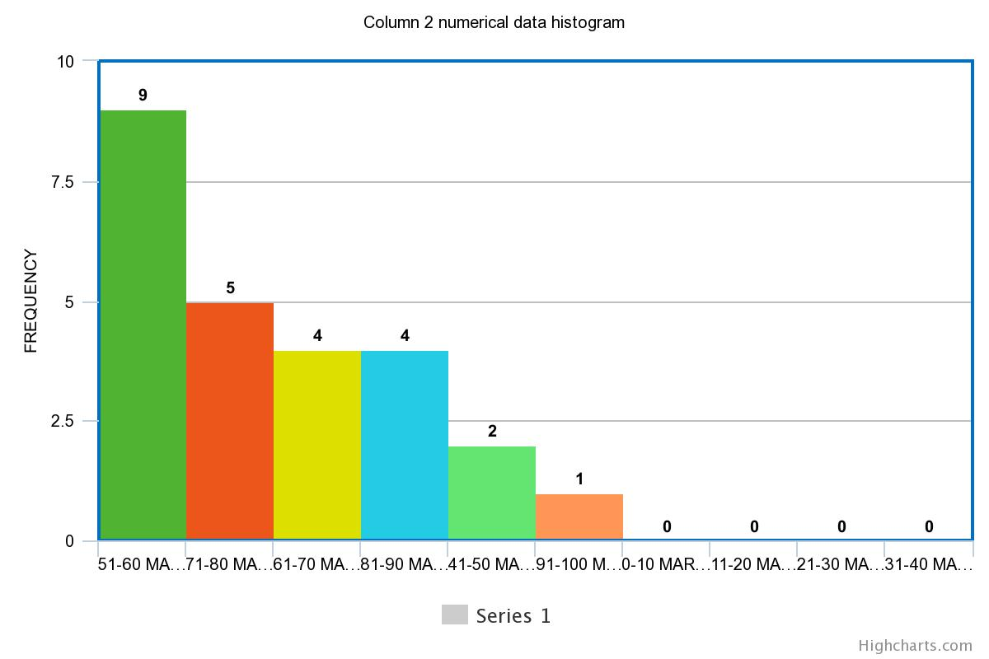
The bin width is medium because too large one cannot identify the local regions and no enough differentiation; thus, too small width the data cannot be grouped.
- Organizing, Summarizing, and Describing Quantitative Data using StatCrunch
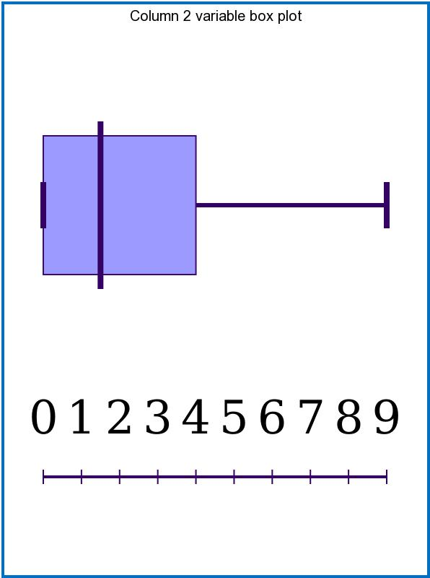
The box plot displays the data quartiles lesser people scored over the upper quartile range while many people scored nearly to lower quartile.
The dot plot shows how frequently the sampled students score a mark. For example, in our data, the dots show how repeatedly a mark between the ranges was scored.
The histogram is a frequency distribution showing how often does a value in a set occurs in the data set. There is a range in marks scored in my data, and my histogram shows how often a certain range scored.
- Minimum value = 45
Maximum value = 92
Mean = 66.08
Median = 64
Mode =56
Q₁ =55
Q₃=78.5
Range=47
IQR =23.5
Standard deviation = 13.314
- The minimum value of the data is 45 marks; herein, this is the least observation in the sample. Thus all students scored more than 45 in the population.
- The maximum value is 92, the highest value scored by the students. This means that no one scored more than 92. Every student scored lesser marks
- The mean mark is 66.08. This means that the average marks scored by each student were 66.08, this meaning that most of the students excelled
- The median score is 64; half of the students scored less than 64, and the other half more than 64 marks.
- The mode mark is 56. Most students are tied in the mark hence being scored by the highest number of students.
- The first quartile mark is 55, which is the mark that shows that a quarter of the population scored less than 55 marks while three-quarters of the students scored more than 55 marks.
- The third quartile mark is 78.5, which implies that three-quarters of the students scored less marks than 78.5, and only a quarter of the population scored more than 78.5.
- The range is 47. The differences scored in between all the marks of the students in the data.
- IQR (interquartile range) is 23.5, the difference between the third and first quartile ranges, thus showing half of the range.
- The standard deviation is 13.314, which shows that the values are 13 values far above and below the mean. This is a low standard deviation, showing that the data is clustered close to the mean; hence my data is more reliable.

- Median is the best measure of the presented data because it is skewed, and the data is also ordinal.
- Standard deviation is the best way to measure spread because the more a standard deviation tends to zero; it indicates that data points are close to the mean.
- The center I found for my data is the point of the data that splits it into two equal parts where the point center of my data set is 64, and the spread of data is how far are the rest of the numbers in data are away from the mean or median.

5. Report on How Many Students Excelled in the Previous Units.
Abstract
The research was based on fourth-year students at Harvard university those who excelled in the previous exam units. Only 30 students were sampled, whereby 25 were responsive, while 5 rejected the idea. Out of the 30 students, each student responded to what mark they got in a random unit.
Research Introduction
The research was based on if the students excelled or they did not excel; despite them excelling or not, we also collected their marks to estimate the average marks scored by fourth-year students at Harvard University. The research also tells if fourth-year students at Harvard university excelled or did not excel.
Research Methodology
During the research, we used a verbal talk while collecting the data of the sampled data. Every student was asked how marks do he or she get on the previous exam paper. This was the only method used in collecting data. Maybe one or more people never told the truth, but I trusted they gave reliable information.
Results
After collecting marks from each of the sampled students, we found that the least mark was 45 while the highest mark was 92. This means that all the students scored between 45 and 92 marks. The mean average mark was 66.08, and the median was 64. Many students scored 56 marks (tied).
Discussions
The fourth-year Harvard university students scored between 45 and 92, meaning that the differences between the range are 92-45=47. The mean average mark was 66.08, meaning every student’s average marks are 66.08.
The median mark was 64, meaning half of the students scored more than 64, and the other half scored less than 64. The first quartile is 55 and the third quartile 78.5; thus, a quarter of the students scored less than 55 and more than 78.5 marks.
Conclusion
The data collected and analyzed shows that each student’s average mark in a single unit was 66.08. Since 66.08 is past the pass mark, the research concludes that a high proportion of Harvard university fourth-year students excelled.

